

# 

### Semester Two Examination, 2017

### Question/Answer booklet

# MATHEMATICS

**SOLUTIONS**

**APPLICATIONS**

**UNITS 1 AND 2**

## Section Two:

## Calculator-assumed

|  |  |  |  |  |  |  |  |  |  |  |
| --- | --- | --- | --- | --- | --- | --- | --- | --- | --- | --- |
| Student Number: In figures |  |  |  |  |  |  |  |  |  |  |

In words

Your name

## Time allowed for this section

Reading time before commencing work: ten minutes

Working time: one hundred minutes

## Materials required/recommended for this section

***To be provided by the supervisor***

This Question/Answer booklet

Formula sheet (retained from Section One)

***To be provided by the candidate***

Standard items: pens (blue/black preferred), pencils (including coloured), sharpener, correction fluid/tape, eraser, ruler, highlighters

Special items: drawing instruments, templates, notes on two unfolded sheets of A4 paper, and up to three calculators approved for use in this examination

## Important note to candidates

No other items may be taken into the examination room. It is **your** responsibility to ensure that you do not have any unauthorised material. If you have any unauthorised material with you, hand it to the supervisor **before** reading any further.

## Structure of this paper

|  |  |  |  |  |  |
| --- | --- | --- | --- | --- | --- |
| Section | Number of questions available | Number of questions to be answered | Working  time (minutes) | Marks available | Percentage of examination |
| Section One:  Calculator-free | 6 | 6 | 50 | 52 | 35 |
| Section Two:  Calculator-assumed | 13 | 13 | 100 | 98 | 65 |
|  | | |  | **Total** | 100 |

## Instructions to candidates

1. The rules for the conduct of examinations are detailed in the school handbook. Sitting this examination implies that you agree to abide by these rules.

2. Write your answers in this Question/Answer booklet.

3. You must be careful to confine your response to the specific question asked and to follow any instructions that are specified to a particular question.

4. Additional working space pages at the end of this Question/Answer booklet are for planning or continuing an answer. If you use these pages, indicate at the original answer, the page number it is planned/continued on and write the question number being planned/continued on the additional working space page.

5. Show all your working clearly. Your working should be in sufficient detail to allow your answers to be checked readily and for marks to be awarded for reasoning. Incorrect answers given without supporting reasoning cannot be allocated any marks. For any question or part question worth more than two marks, valid working or justification is required to receive full marks. If you repeat any question, ensure that you cancel the answer you do not wish to have marked.

6. It is recommended that you do not use pencil, except in diagrams.

7. The Formula sheet is not to be handed in with your Question/Answer booklet.

Section Two: Calculator-assumed 65% (98 Marks)

This section has**thirteen (****13)** questions. Answer **all** questions. Write your answers in the spaces provided.

Working time: 100 minutes.

Question 7 (6 marks)

(a) If concrete can be bought for $260 per cubic metre, calculate the cost per square metre to make a rectangular concrete slab measuring 6.2 m by 8.5 m and with a uniform thickness of 14 cm. (3 marks)

|  |
| --- |
| **Solution** |
|  |
| **Specific behaviours** |
| ✓ calculates slab volume  ✓ calculates slab cost (must include $ symbol to get mark)  ✓ calculates slab cost per m2 |

(b) After pouring another rectangular concrete slab, the builder wanted to check that the corners of the slab were right-angled. The builder measured the diagonal of the slab to be 9.7 m and the sides of the slab to be 7.2 m and 6.5 m.

Use your knowledge of mathematics to determine whether the corners of the slab were right-angled. (3 marks)

|  |
| --- |
| **Solution** |
| As sum of squares of two shorter sides is equal to square of diagonal, then the triangle satisfies Pythagoras' Theorem, and so the angle in the corner is a right-angle. |
| **Specific behaviours** |
| ✓ uses Pythagoras' Theorem [Or applies Cosine Rule]  ✓ adds squares of two shorter sides [Or correctly substitutes values into Cosine Formula]  ✓ writes conclusion |

Question 8 (5 marks)

Six variables are listed below.

A Height of trees

B Hair colour

C Country of birth

D Movie rating using a scale of 1 to 5 stars

E Daily minimum temperature

F Driver's licence number

(a) In the spaces below, write the letter corresponding to **one** of the above of variables that is

(i) a categorical variable that can be classified as ordinal. (1 mark)

|  |
| --- |
| **Solution** |
| D or F |
| **Specific behaviours** |
| ✓ suitable variable |

(ii) a numerical variable that can be classified as continuous. (1 mark)

|  |
| --- |
| **Solution** |
| A or E |
| **Specific behaviours** |
| ✓ suitable variable |

(iii) a categorical variable that can be classified as nominal. (1 mark)

|  |
| --- |
| **Solution** |
| B or C |
| **Specific behaviours** |
| ✓ suitable variable |

(b) Give an example of a numerical variable that is not listed above and can be classified as discrete. Explain why it has this classification. (2 marks)

|  |
| --- |
| **Solution** |
| Number of students in a class, etc, etc.  The value of such variables can be obtained by counting. |
| **Specific behaviours** |
| ✓ suitable variable  ✓ explanation |

Question 9 (6 marks)

From the top of a m tall building, the angle of depression to a small dog sitting on a path, level with the base of the building, is .

(a) Calculate the distance the dog is from the base of the building. (3 marks)

|  |
| --- |
| **Solution** |
|  |
| **Specific behaviours** |
| ✓ sketch diagram with measurements  ✓ uses tangent ratio [Or applies Sine rule]  ✓ states distance |

The dog walks m directly towards the building and then stops.

(b) Determine the angle of elevation from the dog to a window positioned m below the top of the building. (3 marks)

|  |
| --- |
| **Solution** |
| (26.35 accepted) |
| **Specific behaviours** |
| ✓ sketch with new measurements  ✓ uses tangent ratio [Must use the ratio correctly, did not accept Adj/Opp; Alternatively, they can apply the Cosine Law to find the missing angle after calculating the missing sides]  ✓ states angle [did not penalize a missing angle symbol o] |

Question 10 (9 marks)

A young person won $24 000. Not needing the money immediately, they bought 1 600 AAF shares, 800 TTE shares and placed the remaining $5 600 in a deposit account.

(a) During the first year, dividends were paid of 44 cents per share for AAF and of 5.5% on the value of the TTE shares, which were priced at $7.85 at the time. Calculate the total dividend paid. (3 marks)

|  |
| --- |
| **Solution** |
| AAF:  TTE:  Total: |
| **Specific behaviours** |
| ✓ dividend per share  ✓ dividend as %  ✓ total dividend |

(b) The deposit account paid 4.5% per annum interest, compounded annually. Calculate the interest that would accumulate in the account

(i) during the first year. (1 mark)

|  |
| --- |
| **Solution** |
|  |
| **Specific behaviours** |
| ✓ uses simple interest |

(ii) during the second year. (2 marks)

|  |
| --- |
| **Solution** |
|  |
| **Specific behaviours** |
| ✓ new principle  ✓ states interest  Alternatively:  ✓ Calculates the total interest for 2 years  ✓ Subtracts the principle and simple interest from total. |

(c) After two years the young person valued the total of their shares, the dividends received and the money in the deposit account at $26 382.50. Calculate, to one decimal place, the percentage increase in the value of their winnings. (3 marks)

|  |
| --- |
| **Solution** |
|  |
| **Specific behaviours** |
| ✓ indicates increase Alternatively:  ✓ calculates percentage ✓Divides New amount by Initial amount  ✓ rounds correctly ✓States 1.099 or 109.99%  ✓Rounds correctly and states 9.9% |
|  |

Question 11 (8 marks)

The net shown below, made from four rectangles and two trapeziums, is folded to form a scale model of a shed with a sloping roof.

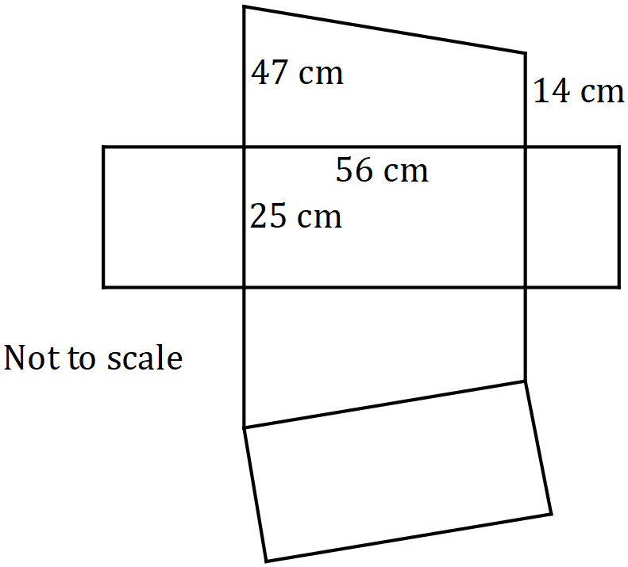

(a) Calculate the volume of the completed model. (3 marks)

|  |
| --- |
| **Solution** |
|  |
| **Specific behaviours** |
| ✓ uses trapezium as cross- section [Or applies Volume of rectangular prisms]  ✓ calculates area of trapezium  ✓ calculates volume [Must be in cm3] |

(b) Determine the total surface area of the completed model. (5 marks)

|  |
| --- |
| **Solution** |
| Three rectangles:  Triangle:  Sloping edge:  Roof area:  TSA: |
| **Specific behaviours** |
| ✓ calculates areas of three rectangles  ✓ dimensions of triangle  ✓ uses Pythagoras' theorem for length of roof  ✓ area of roof  ✓ sums six areas for TSA [No mark for this point if multiple areas are missing] |

Question 12 (6 marks)

The network below shows direct bus services between five city landmarks, and . For example, a direct bus service exists between and but not between and .

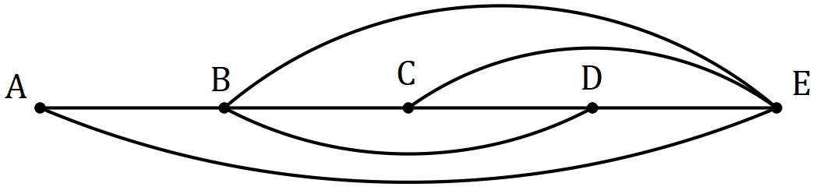

(a) Represent this information in a matrix , with row and column headings in alphabetical order. (2 marks)

|  |
| --- |
| **Solution** |
|  |
| **Specific behaviours** |
| ✓ at least 3 correct rows  ✓ all rows correct |

(b) Calculate , state the value of entry and explain what this value means. (3 marks)

|  |
| --- |
| **Solution** |
| There are 3 ways to travel from to using 2 bus services. |
| **Specific behaviours** |
| ✓ correct matrix  ✓ correct element  ✓ explanation |

(c) In how many ways is it possible to use four bus services to start a journey at and finish at ? (1 mark)

|  |
| --- |
| **Solution** |
|  |
| **Specific behaviours** |
| ✓ correct number of ways |

Question 13 (10 marks)

The spreadsheet below shows the wages sheet for some of the staff at a restaurant that is closed on Mondays and Tuesdays. Employees are paid time-and-a-half on Saturdays and double time on Sundays.

|  |  |  |  |  |  |  |  |  |
| --- | --- | --- | --- | --- | --- | --- | --- | --- |
|  |  |  | Hours worked | | | | |  |
| Employee | Base Pay Rate |  | Wed | Thu | Fri | Sat | Sun | Weekly Pay |
|  | ($ per hour) | Rate | 1 | 1 | 1 | 1.5 | 2 | ($) |
| Andi | 15.50 |  | 8 | 6 | 7 | 0 | 0 | **A** |
| Bi | 25.50 |  | 0 | 0 | 5 | 6 | 8 | **B** |
| Chi |  |  | 0 | 4 | 0 | 8 | 0 | 294.40 |
| Di | 16.20 |  | 0 | 7 | 7 | 0 | **C** | 324.00 |
| Elli | 22.80 |  | 6 | 0 | 6 | 5 | 0 | 444.60 |

(a) Calculate the total wages paid to employees on Wednesday. (2 marks)

|  |
| --- |
| **Solution** |
|  |
| **Specific behaviours** |
| ✓ uses correct rates and hours  ✓ correct total |

(b) Determine the values of A, B and C in the table. (4 marks)

|  |
| --- |
| **Solution** |
|  |
| **Specific behaviours** |
| ✓ value of A  ✓ value of B  ✓ calculates total hours or writes equation for Di  ✓ value of C |

(c) The restaurant is liable for payroll tax at a rate of 5.5% of all staff payments. Calculate the payroll tax the restaurant must pay this week for the five employees. (2 marks)

|  |
| --- |
| **Solution** |
|  |
| **Specific behaviours** |
| ✓ correct total  ✓ multiplies total by 0.055, rounding to dollars and cents |

(d) Determine Chi's base rate of pay. (2 marks)

|  |
| --- |
| **Solution** |
|  |
| **Specific behaviours** |
| ✓ total weighted hours  ✓ states hourly rate (F.T. from hours if incorrect) |

Question 14 (7 marks)

The number of nights that visitors booked hotel rooms for via a new phone app on the first day in March this year are summarised in the table below.

|  |  |  |  |  |  |  |  |  |  |  |
| --- | --- | --- | --- | --- | --- | --- | --- | --- | --- | --- |
| Number of nights | 1 | 2 | 3 | 4 | 5 | 6 | 7 | 8 | 9 | 10 |
| Frequency | 31 | 33 | 18 | 9 | 11 | 10 | 5 | 2 | 1 | 1 |

(a) For this data, determine

(i) the total number of nights booked by visitors. (1 mark)

|  |
| --- |
| **Solution** |
| Total nights: 372  Mean: 3.07 nights (3.1 accepted)  SD: 2.06 nights (2.1 accepted) |
| **Specific behaviours** |
| ✓ states number of nights  ✓ states mean  ✓ states SD |

(ii) the mean number of nights booked. (1 mark)

(iii) the standard deviation of the number of nights booked. (1 mark)

(b) Briefly comment on the distribution of this data. (1 mark)

|  |
| --- |
| **Solution** |
| The data is positively skewed. |
| **Specific behaviours** |
| ✓ identifies positive skew |

(c) Identify, with justification, whether the data contains an outlier. (3 marks)

|  |
| --- |
| **Solution** |
| Hence the booking for 10 nights is an outlier, as it exceeds 9.75. |
| **Specific behaviours** |
| ✓ indicates IQR  ✓ uses criteria  ✓ identifies outlier |

Question 15 (7 marks)

A scientific study showed that the lengths of a species of caterpillars are normally distributed with a mean and standard deviation of 5.35 cm and 0.42 cm respectively.

(a) If a caterpillar is selected at random from those in the study, determine the probability that it's length is

(i) less than 5 cm. (1 mark)

|  |
| --- |
| **Solution** |
|  |
| **Specific behaviours** |
| ✓ correct probability |

(ii) within 0.6 cm of the mean. (2 marks)

|  |
| --- |
| **Solution** |
|  |
| **Specific behaviours** |
| ✓ indicates lower and upper bounds  ✓ correct probability (F.T. probability from incorrect boundaries) |

(b) If the lengths of 95% of the caterpillars were between cm and cm, determine the value of . (2 marks)

|  |
| --- |
| **Solution** |
|  |
| **Specific behaviours** |
| ✓ indicates within 2 sd of mean  ✓ states  Alternatively:  ✓ between 4.53 and 6.17  ✓ 0.82cm |

(c) If 250 caterpillars were selected at random, how many would be expected to have lengths of at least 6 cm? (2 marks)

|  |
| --- |
| **Solution** |
|  |
| **Specific behaviours** |
| ✓ calculates proportion  ✓ states correct whole number |

Question 16 (8 marks)

The diagram shows points and on the circumference of a circle with centre and radius cm. Angle and angle are both °.

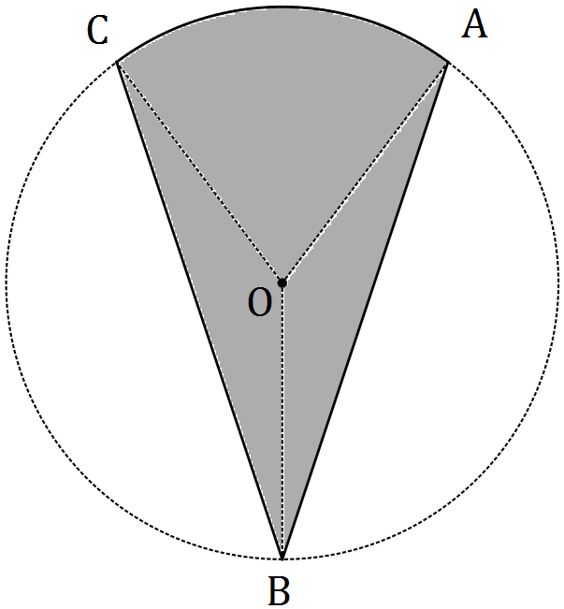

(a) Calculate the area of triangle . (2 marks)

|  |
| --- |
| **Solution** |
|  |
| **Specific behaviours** |
| ✓ uses area formula  ✓ states area |

(b) Determine the size of angle . (1 mark)

|  |
| --- |
| **Solution** |
|  |
| **Specific behaviours** |
| ✓ states angle |

(c) Calculate the area of the shaded region . (3 marks)

|  |
| --- |
| **Solution** |
|  |
| **Specific behaviours** |
| ✓ substitutes into sector area formula  ✓ calculates sector area  ✓ calculates total area (f.t. if sector area incorrect) |

(d) Determine the new area of the shaded region if the radius of the circle was increased from cm to cm. (2 marks)

|  |
| --- |
| **Solution** |
| (6662 paid) |
| **Specific behaviours** |
| ✓ indicates scale factor  ✓ states new area |

Question 17 (9 marks)

Five equilateral triangles are joined together to make a trapezium with perimeter of length 154 cm, as shown below.

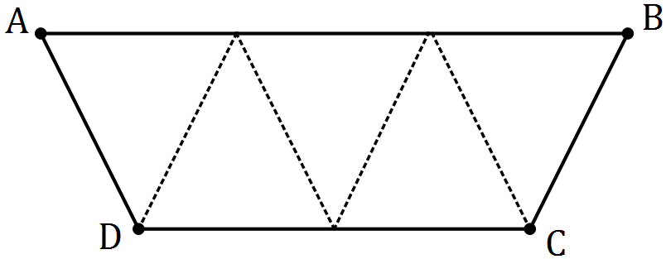

(a) Explain why the sides of each triangle must be 22 cm long. (2 marks)

|  |
| --- |
| **Solution** |
| There are 7 equal length sides making the perimeter. So cm. |
| **Specific behaviours** |
| ✓ indicates 7 equal length sides  ✓ uses division |

(b) Use Heron's rule to calculate the area of **one** of the triangles. (3 marks)

|  |
| --- |
| **Solution** |
|  |
| **Specific behaviours** |
| ✓ calculates semi-perimeter  ✓ substitutes into Heron's  ✓ calculates area |

(c) Determine the area of the trapezium. (1 mark)

|  |
| --- |
| **Solution** |
|  |
| **Specific behaviours** |
| ✓ states area |

(d) Determine the length of diagonal in the trapezium. (3 marks)

|  |
| --- |
| **Solution** |
|  |
| **Specific behaviours** |
| ✓ indicates lengths , and angle  ✓ uses cosine rule  ✓ states length |

Question 18 (8 marks)

Two similar cylindrical containers, both open at the top and full of water, are made from thin steel. The smaller container has an internal radius of 20 cm and height of 15 cm, and the larger a radius of 42 cm.

Neither cylinder, shown below, has a lid.

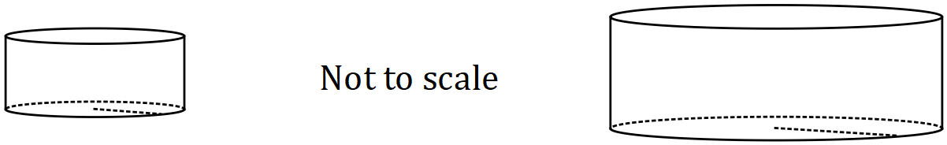

(a) Using the fact that the cylinders are similar, determine the height of the large cylinder.

(2 marks)

|  |
| --- |
| **Solution** |
|  |
| **Specific behaviours** |
| ✓ indicates scale factor (or ratio of dimensions)  ✓ states height |

(b) Calculate the internal surface area (the area in contact with water) of the small cylinder.

(2 marks)

|  |
| --- |
| **Solution** |
| (3141.59) |
| **Specific behaviours** |
| ✓ indicates sum of base and wall  ✓ states area, reasonable rounding |

(c) 200 mL of paint was required to coat the inside of the small cylinder. Determine how much paint was required to coat (to the same thickness) the inside of the larger cylinder.

(2 marks)

|  |
| --- |
| **Solution** |
|  |
| **Specific behaviours** |
| ✓ uses area scale factor  ✓ states amount |

The small cylinder is emptied and water from the large cylinder is then used to refill the small cylinder.

(d) How many times can the water from the large cylinder be used to completely refill the small cylinder? Justify your answer. (2 marks)

|  |
| --- |
| **Solution** |
|  |
| **Specific behaviours** |
| ✓ uses volume scale factor  ✓ states correct number (must quote 9) |

Question 19 (9 marks)

Some currency exchange rates advertised by an Australian bank for one Australian dollar are shown in the table below.

|  |  |  |
| --- | --- | --- |
| Country (currency) | Buy rate | Sell rate |
| Denmark (kroner) | 5.8220 | 4.4210 |
| Switzerland (franc) | 0.8850 | 0.7110 |
| South Korea (won) | 872.7557 | 768.4547 |
| Thailand (baht) | 28.3350 | 24.8850 |

(a) The midrate is the average of the buy and sell rates. Calculate the midrate for Swiss franc. (1 mark)

|  |
| --- |
| **Solution** |
|  |
| **Specific behaviours** |
| ✓ states midrate |

(b) If a Swiss tourist in Australia wanted to exchange 530 francs for Australian currency, explain why the bank would use the buy rate, and calculate how many Australian dollars they would receive. (2 marks)

|  |
| --- |
| **Solution** |
| The bank is *buying* foreign currency, so will use buy rate. |
| **Specific behaviours** |
| ✓ explains rates quoted from banks point of view  ✓ calculates amount |

(c) The same product, including shipping, can be bought online from a South Korean website for 175 000 won or a Danish website for 900 kroner. Compare these prices in dollars for an Australian purchaser and calculate the amount saved by buying from the cheaper site.

(3 marks)

|  |
| --- |
| **Solution** |
|  |
| **Specific behaviours** |
| ✓ uses sell rates for conversions  ✓ converts both to AUD  ✓ states saving (f.t. from previous if subtraction seen - $45.92) |

(d) An Australian traveller exchanged $900 into Thai baht, spent 18 000 baht whilst away and then converted the remainder back into Australian dollars on their return. How much did the traveller receive back? (3 marks)

|  |
| --- |
| **Solution** |
|  |
| **Specific behaviours** |
| ✓ uses correct rates **both** ways  ✓ converts to baht and subtracts spending  ✓ converts back to AUD (f.t. paid) |

Additional working space

Question number: _________

Additional working space

Question number: _________

Additional working space

Question number: _________

Additional working space

Question number: _________

© 2017 WA Exam Papers. Kennedy Baptist College has a non-exclusive licence to copy and communicate this document for non-commercial, educational use within the school. No other copying, communication or use is permitted without the express written permission of WA Exam Papers. SN245-103-4.